1. To join the zoom meeting click this link: <https://zoom.us/j/98655940891>
2. A webpage will load with a pop up asking if you want to open zoom meetings – click open zoom meetings

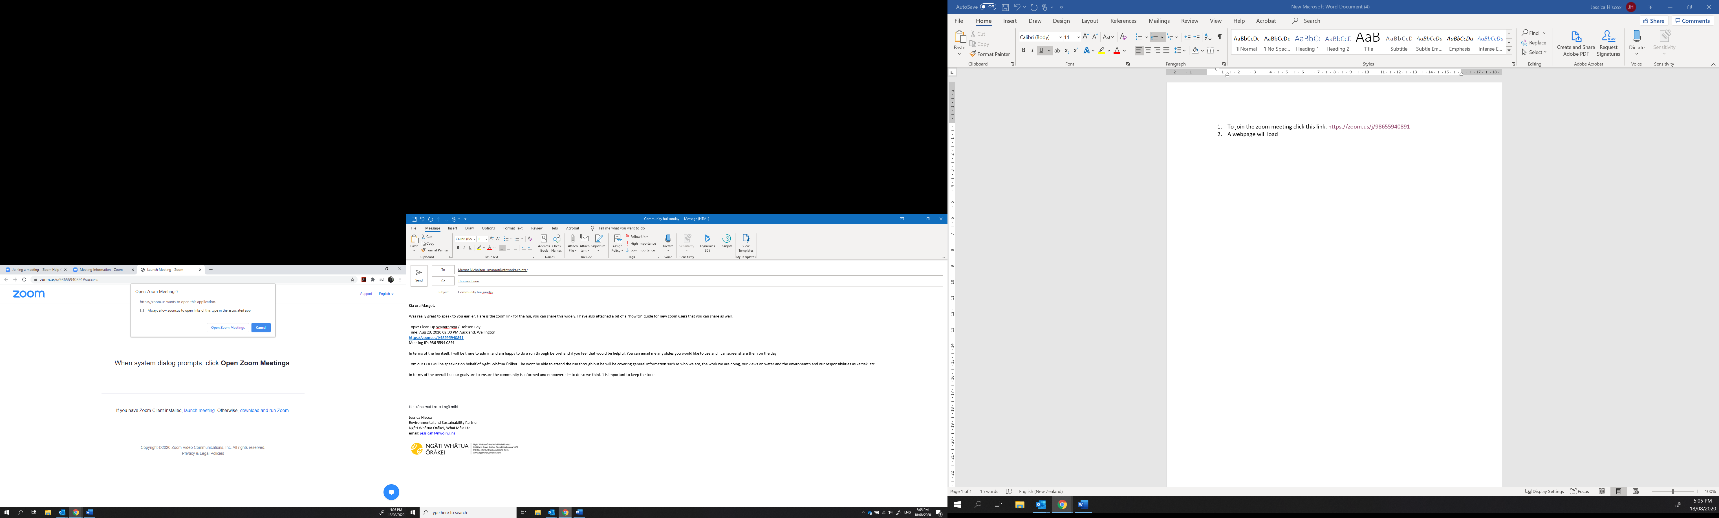

1. If asked, enter the meeting ID 986 5594 0891 and your name (which will be displayed to all viewers), You do not need to download the zoom app to your computer

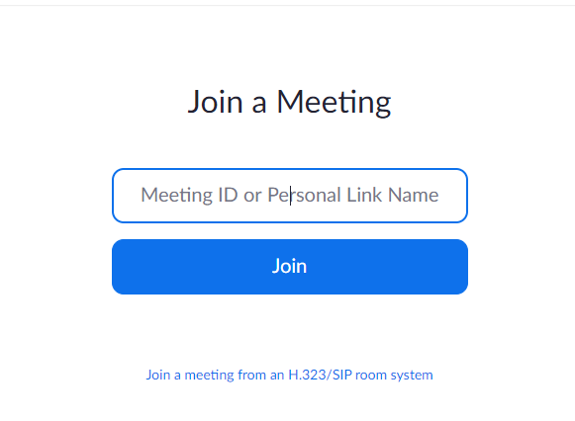

1. A new window will pop up – click “join with computer audio”. Please note, your microphone will be muted when you enter. Please leave it muted for the hui to avoid background noise

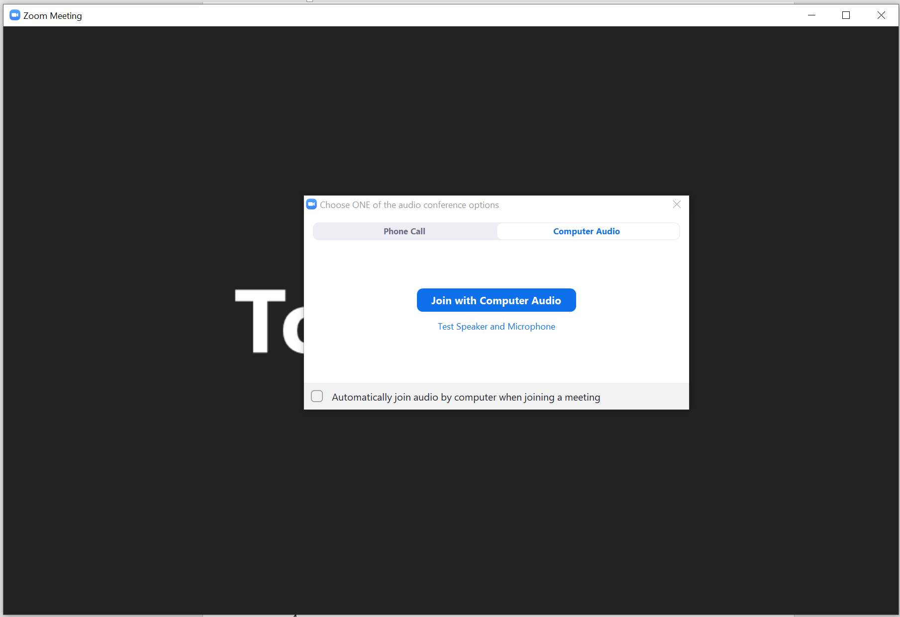

1. If you have any questions, please click the chat button and type your questions – this will be monitored during the presentations and we will ask them all at the end

